Lab Task # 01

Take an input sentence (maximum length N = 100) and perform the following operations on the sentence.

- Length of the sentence
- Sentence in lowercase
- Sentence in uppercase
- Number of words in the sentence
- Number of vowels
- Frequency of the vowels

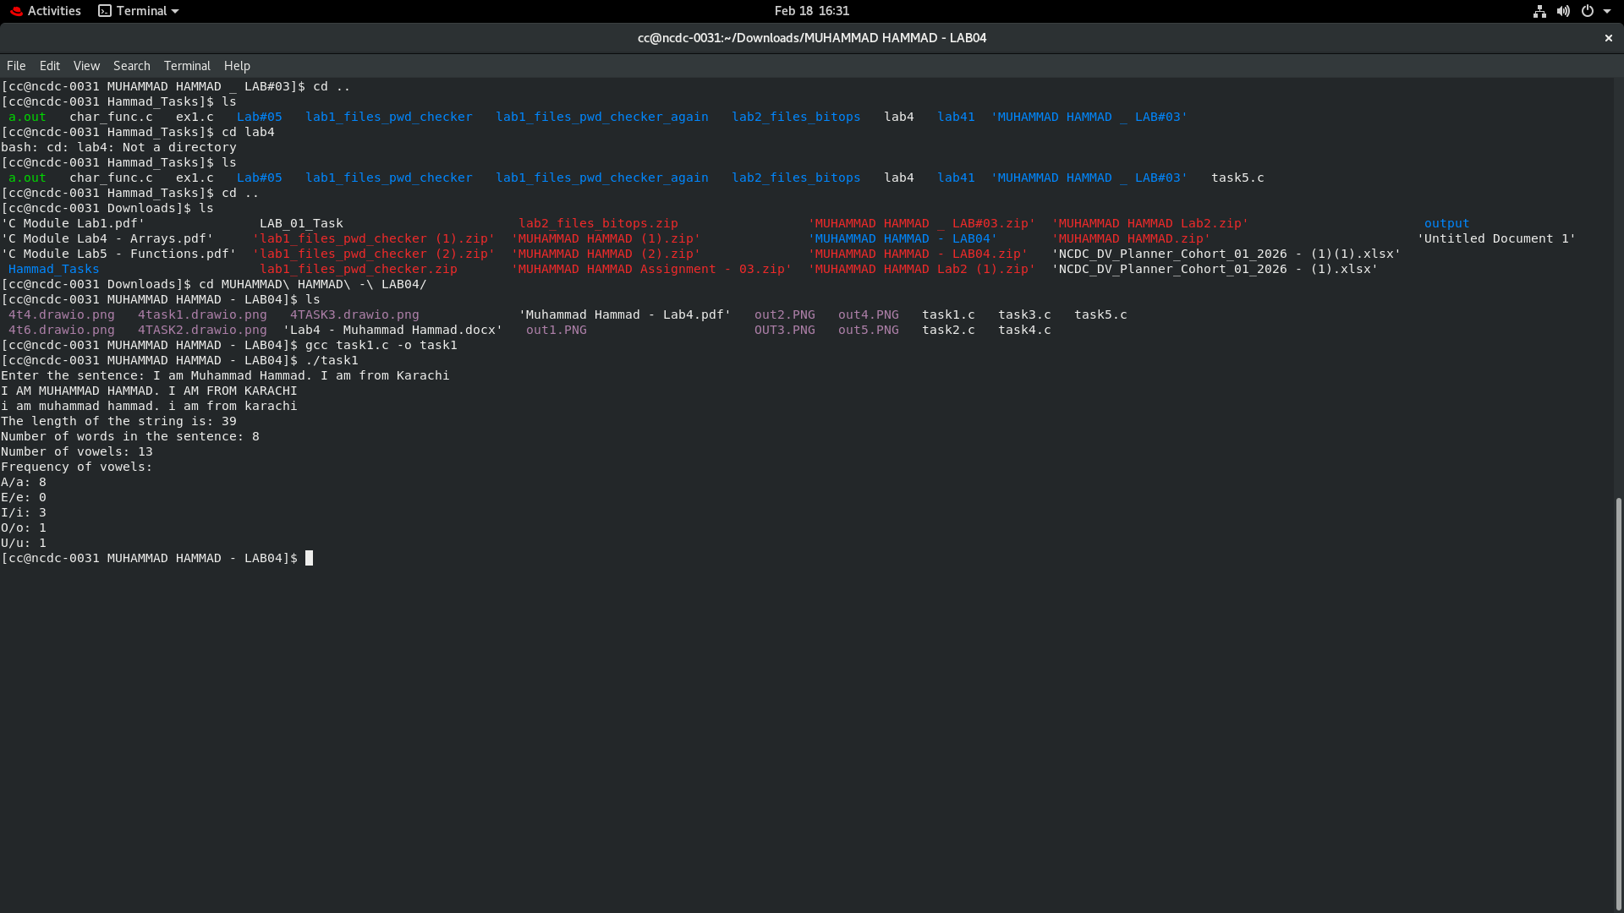
Output:

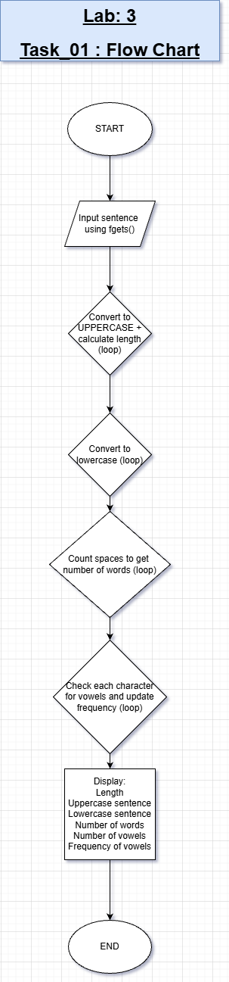
Flow Chart

Lab Task # 02

Level 1 Operations - axpy (ax + by)
Write a program which takes inputs a, x, b and y from the user (x, y are vectors of size N) and a and b are scalars. Your program should then compute the above operation.
Flow Chart: 15 Minutes Code: 15 Minutes
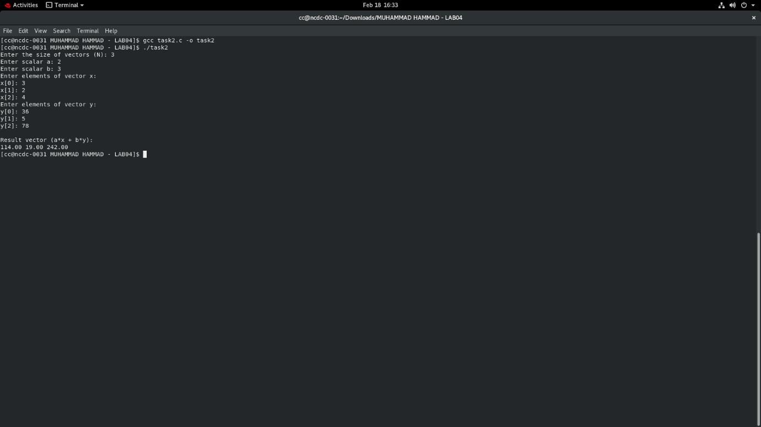
Output:

Flow Chart
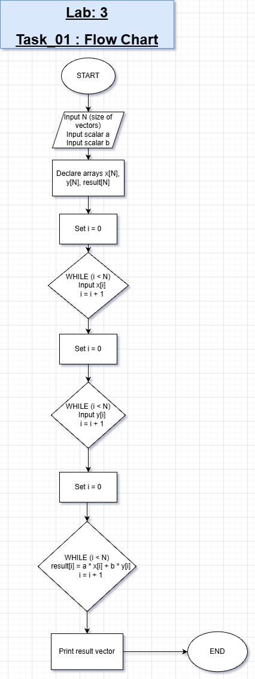

Lab Task # 03
Write a program that declares an integer array of size 10. Initialize the array
element with random numbers in the range 1-20 and graph the information as a histogram as shown:
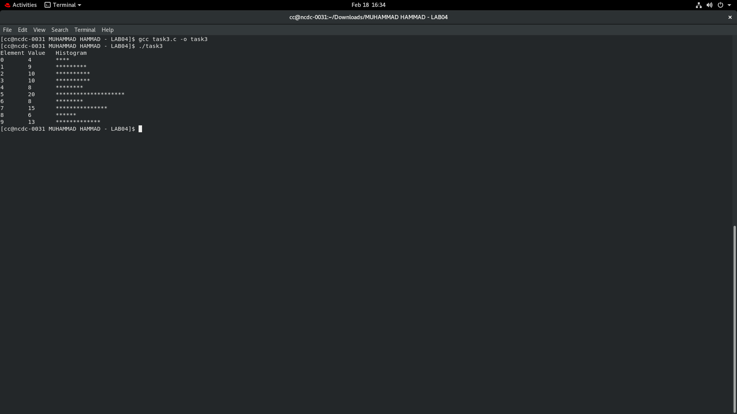
Flow Chart: 25 Minutes Code: 20 Minutes

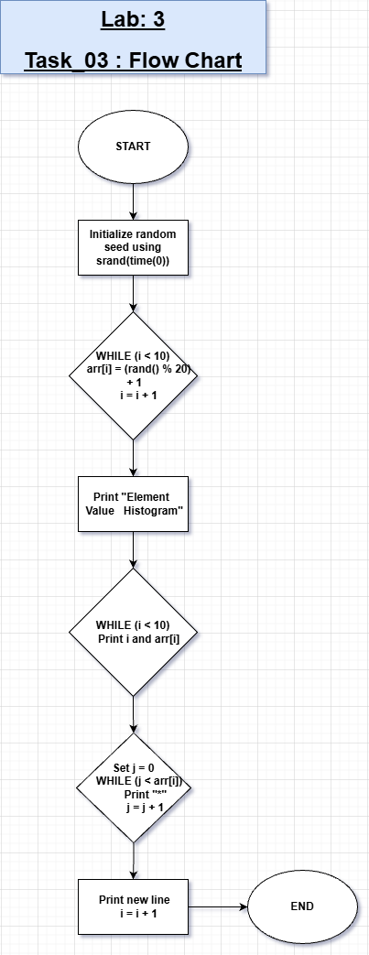

Lab Task # 04

Level 3 Operations - Matrix Multiplication (C=AB)
Write a program which takes inputs A and B from the user (A is of size M x N, B is of size NxK) and compute the matrix matrix multiplication.
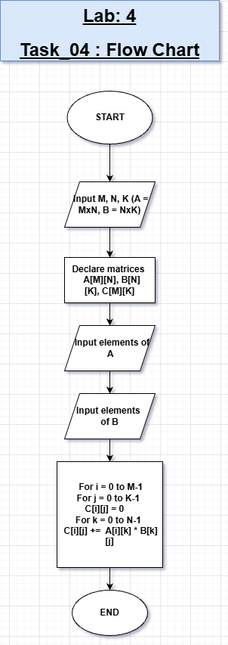
Flow Chart: 30 Minutes Code: 30 Minutes

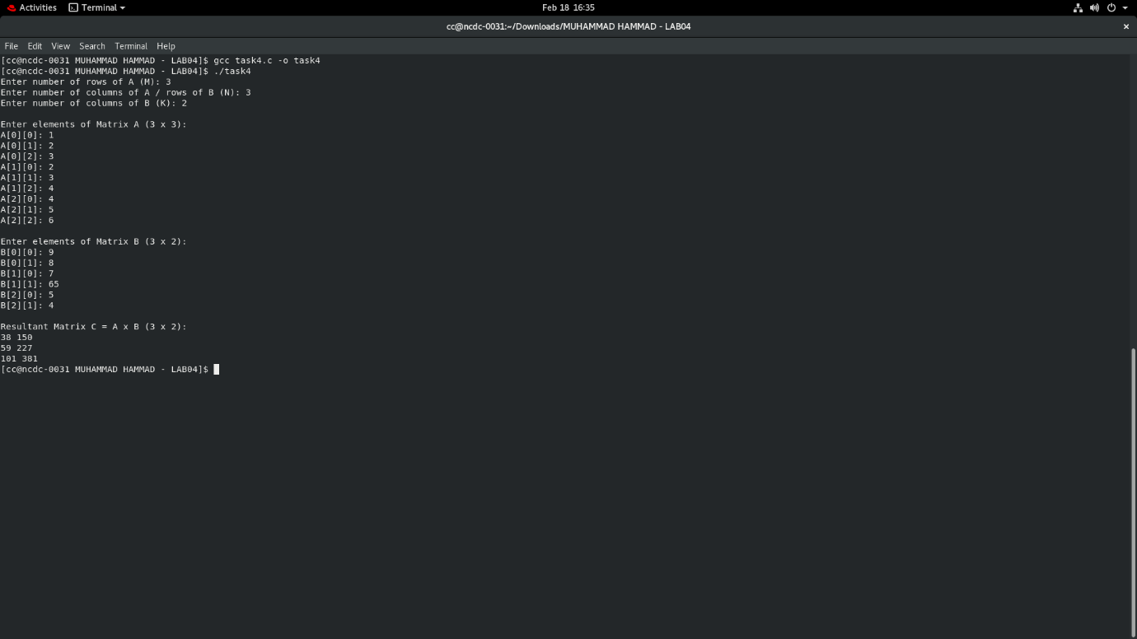

Lab Task # 05

Signal Processing
Consider a 1D AC sinusoidal voltage signal that is digitized and is stored in the computer.
- What data type will be used to store v(t) for these values of t? Initialize v(t) as well.
- Write a program (flow chart) to compute the DC (average) value of the sinusoidal signal. iii. Modify the program to detect when the signal crosses the x-axis. iv. Modify the program to detect the glitches in the signal.
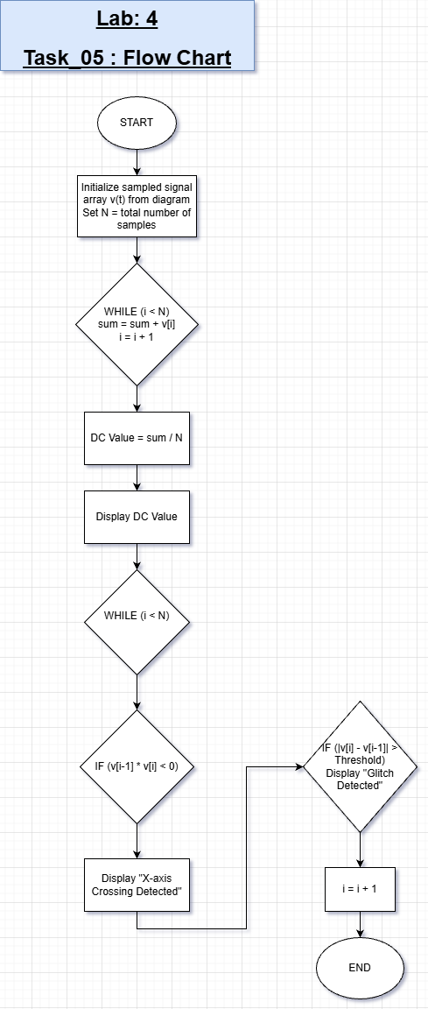
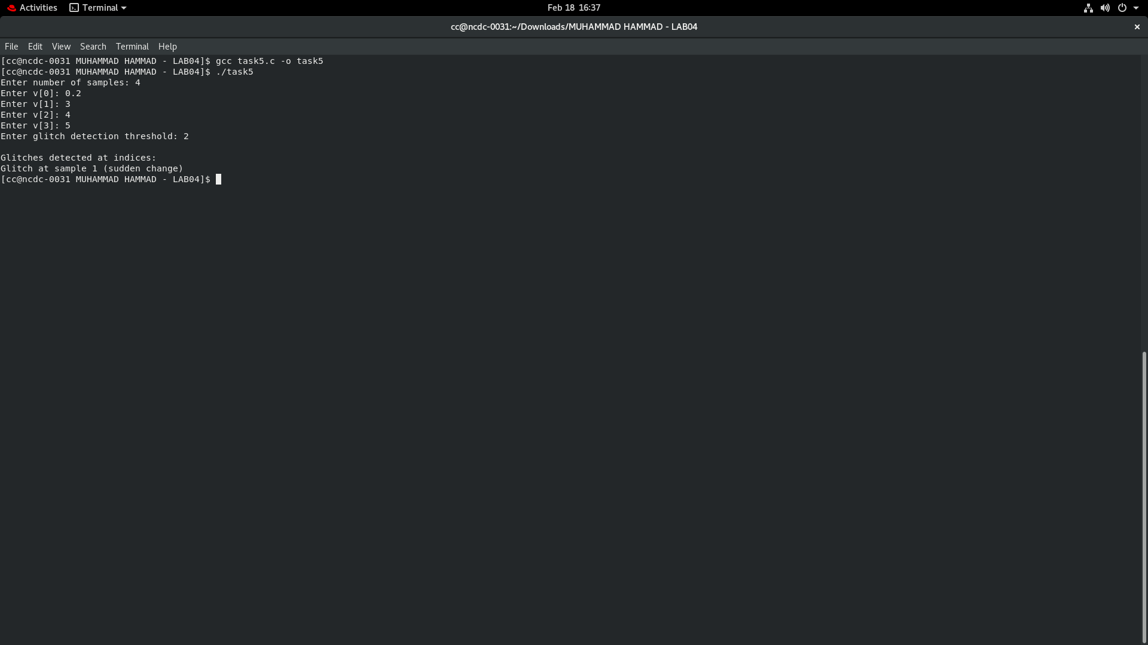

Conclusion:

Lab Task #01: Sentence Operations
Objective:
- Analyze a sentence (max 100 chars): length, words, vowels, case conversion, vowel frequency.
Operations Performed:
- Length calculation: Iterates over characters until \0 or \n.
- length = length + 1;
- Uppercase conversion: If lowercase letter, subtract 32 from ASCII.
- Lowercase conversion: If uppercase letter, add 32 to ASCII.
- Word count: Count spaces + 1.
- Vowel count and frequency: Checks each character against 'a','e','i','o','u' and uppercase equivalents.
Important Functions / Operations:
- fgets() – Input a string including spaces
- printf() – Output
- ASCII manipulation for case conversion
- Iteration using while loops
- Conditional statements (if) for vowels
Conclusion:
- Learned string manipulation in C.
- Manual operations helped understand ASCII, loops, and conditionals.
- Provides foundation for text processing tasks

Lab Task #02: Vector Operation ax + by
Objective:
- Compute result = a*x + b*y for two vectors x and y of size N.
Operations Performed:
- Input size N, scalars a, b.
- Input vectors x and y.
- Loop through elements to compute result[i] = a*x[i] + b*y[i].
- Print the resulting vector.
Important Functions / Operations:
- scanf() – Input numbers
- Loops for element-wise operations
- Arithmetic operations for scalar-vector multiplication and addition
Conclusion:
- Demonstrates basic linear algebra operations.
- Element-wise operations and loops are essential in vector calculations.

Lab Task #03: Histogram of Random Array
Objective:
- Generate an array of size 10 with random numbers (1–20) and display histogram.
Operations Performed:
- Initialize array using rand() % 20 + 1.
- Display index, value, and histogram using *.
- Loop through array elements and print stars equal to value.
Important Functions / Operations:
- rand() and srand(time(0)) – Random number generation
- Nested loops – For printing histogram
- printf() – Display array and histogram
Conclusion:
- Learned array initialization with random numbers.
- Visualized data using a simple histogram.
- Fundamental for data representation tasks.

Lab Task #04: Matrix Multiplication (C = A*B)
Objective:
- Multiply matrices A (MxN) and B (NxK) to get C (MxK).
Operations Performed :
- Input dimensions M, N, K.
- Input matrix elements.
- Compute multiplication using three nested loops:
- for(i=0;i<M;i++){
- for(j=0;j<K;j++){
- C[i][j]=0;
- for(k=0;k<N;k++){
- C[i][j]+=A[i][k]*B[k][j];
- }
- }
- }
- Print resulting matrix.
Important Functions / Operations:
- Loops (nested for) for matrix multiplication
- printf() for displaying results
- Array indexing for matrices
Conclusion:
- Learned matrix multiplication manually in C.
- Reinforced understanding of nested loops and 2D arrays.
- Essential for linear algebra and scientific computing.

Lab Task #05: Signal Processing (Glitch Detection)
Objective:
- Detect glitches in a digitized 1D AC signal.
Operations Performed (as per your code):
- Input number of samples N.
- Input signal array v[N].
- Input threshold for glitch detection.
- Loop through samples and compare consecutive differences:
- if(fabs(v[i] - v[i-1]) > threshold)
- printf("Glitch at sample %d\n", i);
- Prints indices where sudden change occurs.
Important Functions / Operations:
- fabs() from <math.h> for absolute value of floats
- Loops for comparing consecutive samples
- Conditional statements for threshold checking
- printf() for reporting glitches
Conclusion:
- Learned basic digital signal analysis.
- Detecting glitches is critical for signal integrity.
- Combines arrays, loops, and math operations.

General Key Concepts Across All Labs
- Arrays & Loops: Fundamental for storing and processing multiple values.
- Conditional Statements: Used for vowels, word counting, glitch detection.
- Math Functions: fabs() and arithmetic for signals and linear algebra.
- Random Number Generation: rand(), srand(time(0)) for array initialization.
- String Handling: fgets(), ASCII manipulation, while loops for string operations.
- Nested Loops: Essential for matrix multiplication and histograms.
- Input/Output: scanf(), printf() – Standard for interactive C programs.

